OWL Technical Description:

Ontology Makeup:

* Classes:
  + Cell_Surface_Markers
    - Contains all markers with their expressions. For example, “CD3” has two classes: “CD3+” and “CD3-”
  + CellTypes
    - Contains all cell types organized based on Maeker et al.’s structure in Figure 2
    - Subclass “Newly_Discovered_Cell_Types” is where all the examples I tested are located.
* 1 Object Property:
  + HasMarkerExpression
    - Domain: CellTypes
    - Range: Cell_Surface_Markers

Instructions:

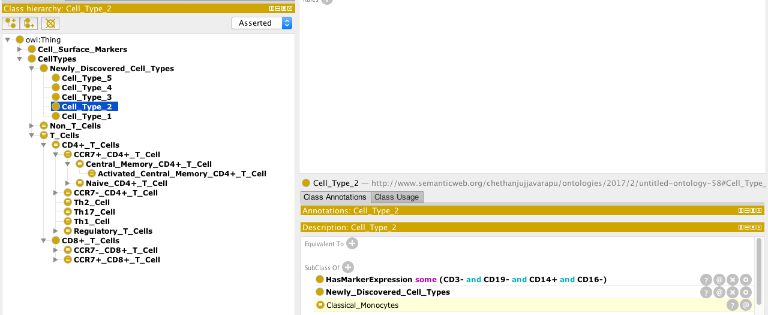

* As shown above, a new user would create a new cell type under the “Newly_Discovered_Cell_Types” class, add “Subclass Of” characteristics, and use the “HasMarkerExpression” to connect the class to specific subclasses of the “Cell_Surface_Markers” Class.
* The ontology will use the reasoner to classify the new cell type.

SWRL rules Technical Description:

Ontology Makeup:

* Classes:
  + Cell_Surface_Markers
    - Contains all markers with their expressions. For example, “CD3” has two classes: “CD3+” and “CD3-”
  + CellTypes
    - Contains all cell types organized based on Maeker et al.’s structure in Figure 2
    - Subclass “Newly_Discovered_Cell_Types” is where all the examples I tested are located.
* 1 Object Property:
  + HasMarker

Instructions:

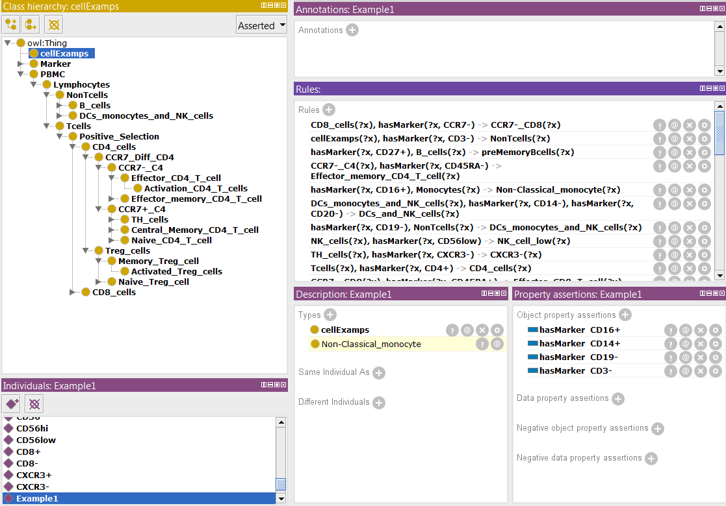

* As shown above, a new user would create a new cell type individual under the “cellExamps” class, add cell marker to link the various cell markers to the example.
* The ontology will use the reasoner to classify the new cell type.